Allegheny County Policing Project

Midterm Update

Team: Lingfeng (Frank) Fan, Anthony Lucchitti, Frederik Sorg-Taylor & Aaron Palmer

**Onboarding Challenges**

We experienced many challenges during the onboarding phase of the project. The first obstacle faced after being assigned this project was understanding what the Allegheny County Policing Project is, who is involved in the project, and what exactly our work would be this semester. The folks from CAASI were welcoming and offered us many resources to acclimate ourselves to the project’s motivation; while the resources were helpful, it was overwhelming at times to sift through the many videos, articles, and Google Drive folders. Nonetheless, we came together as a team and were excited to start working on the project.

Then came the question of what exactly we would be working on. It seemed as if every person we talked to had a different set of goals. The CS 1980 website contained a description of changes to be made this semester, the folks at CAASI listed off their own set of improvements they would like to see, and the resources shared with us listed off additional enhancements derived from conducting user studies. How were we supposed to aggregate these into a concrete set of goals? It was challenging to say the least, but we learned the importance of communication and compromise when working in a client-consultant relationship.

After nailing down a concrete set of goals for the semester, it was time to dig into the code. We as a team followed the explicit guide for setting up the environment locally and had only a few problems running the server on our machines. We began inspecting the code and understanding the general structure of the website. Perhaps naively but arguably logically, all of us cloned the master branch. We assumed the currently deployed website was based off the master branch and that we would create branches off of master to add our features. Little did we know, the master branch is neither the branch in deployment nor the branch our work would be based off of. The team later clarified this and we remedied any confusion. The branch we are working on has a slightly different implementation of the search bar functionality, and *this changed our goals regarding this feature*. The takeaway here was learning the importance of confirming that the assumptions being made are in fact accurate. After later working through a few local deployment issues on the proper branch, we were finally ready to begin work.

**Goals Completed**

**Improve Access to Search Bar Functionality:**

It is a relatively easy task to achieve as the first frontend task. We rearrange the existing React frontend framework to migrate the location of the search bar to the upper level interface, which saves the user an unnecessary step to redirect the page and makes the searching functionality clear and easy-accessible.

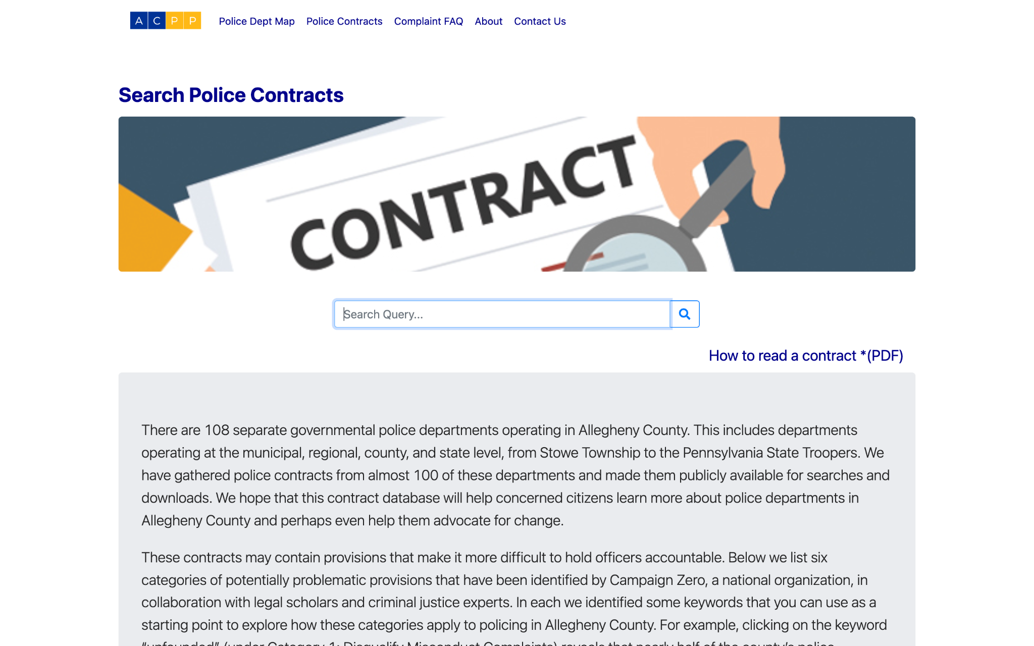

**Enhance Search Bar Functionality - Stop Word Removal**

In an effort to create a more convenient experience for users interacting with the search bar, we successfully removed stop words from both the back end query as well as the front end text highlighting. The screenshot below illustrates the before and after of stop word removal. After presenting this to the ACPP team as well as Brandi from the APA, we received positive feedback that this will help users search for keywords in the contracts.

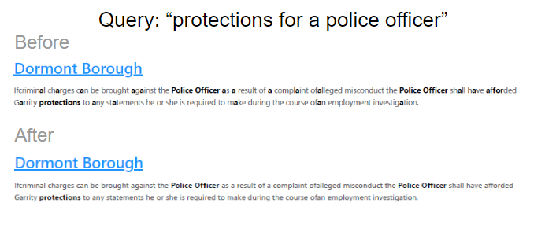

**In-Progress and Future Goals**

**Restructure the Search By Categories:**

When using the Police Contracts search query there is no way to access all of the different search categories. This is inconvenient if you would like to search different keywords concurrently. Users will have to go back to the search categories page and select another keyword. This makes being able to have multiple unique searches difficult for potential first users.

* Create categories that are easily understandable - done
* Scrollable intuitive layout - in-progress
* Each category has related keywords to search by - done
* Stays on search page - in-progress
* Create categories and keywords seamlessly through an easily readable CSV - in-progress

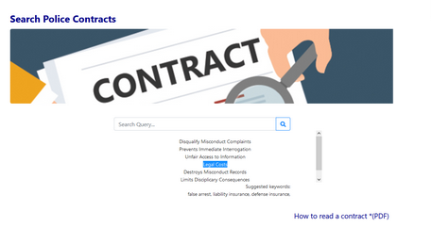

**Link Contract with Preview Text upon Selection**

Currently the search outputs a list of contracts, by county. This list contains highlighted text in preview. However, after clicking on the contract, you are given a PDF or plain text that does not show the search for text visible upon opening.

A solution has not been gathered yet.

**Enhance Search Bar Functionality - Spell Check Enhancements**

* Implement a spell checker which gives spelling suggestions on potentially incorrect words - in-progress

**Enhance Search Bar Functionality - Sort Search Results**

This goal has been added since the beginning of the semester after talking with the ACPP team and Brandi from the APA. The exact implementation details have not been discussed thoroughly and we have not decided on how the front end will change, if at all. Overall, we hope to change the way contracts are returned to the user. Currently, contracts are listed in alphabetical order which does not provide much help to the user given that they can already filter by municipality. Rather than sorting alphabetically, we want to sort the results by best match in an effort to provide the user with the most relevant results at the top of the list.

**Fix Text Parsing Errors**

* Use python library symspellpy to fix text documents
  + Correct incorrectly inserted/deleted spaces
  + Correct misspelled words
* Need to fix formatting issues and uncommon spelling errors.

**Changes in Goals since September**

The goals regarding the search bar functionality changed significantly after realizing the branch we’re working on already solved some of the issues or had details making the goals irrelevant. We therefore had to rethink how we wanted to improve the search bar functionality and pivot our goals. Also, the ‘Link Contract with Preview Text upon Selection’ goal has yet to be explored. We hope to find an implementation by the end of the semester, but are unable to commit to finding an all-inclusive and thorough solution. We may be unaware of changes that will need to be made to our current and future goals, but we hope to accomplish all that is outlined above.